Java Script Data Types

Dynamic typing

Java script is a dynamic language which means that you don’t have to declare the type of variable. The type will automatically be assigned once the code is processed

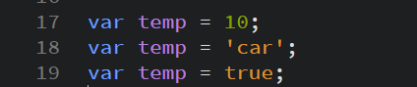

Objects (Properties)

In java script, an object can be seen as a collection of properties. Properties are identified by key values. There are two types of object properties. The data property and the accessor property

Data Property – associates a key with a value

Attributes of the data property:

|  |  |  |  |
| --- | --- | --- | --- |
| Attribute | Type | Description | Default Value |
| [[Value]] | Any | The value returned by a get access of the property | Undefined |
| [[Writable]] | Boolean | If false, the Value cannot be changed | False |
| [[Enumerable]] | Boolean | If true, the property will be iterated in a for loop | False |
| [[Configurable]] | Boolean | If false, the property can be deleted | False |

Attributes of the accessor property:

|  |  |  |  |
| --- | --- | --- | --- |
| Attribute | Type | Description | Default Value |
| [[Get]] | Object | Called with an empty argument list and retrieves the property value whenever it is performed | Undefined |
| [[Set]] | Object | Called when an argument that contains an assigned value is executed | Undefined |
| [[Enumerable]] | Boolean | if true, the property will be iteradted in a for loop | False |
| [[Configurable]] | Boolean | If false, the property cant be deleted or changed | False |